**Modification of mqtt_LED_wifi_encryption**

**Written By Bill Lu**

The purpose of this document is to let you know changes I make to the mqtt_LED_wifi_encryption.ino.

The original mqtt_LED_wifi_encryption.ino’s EEPROM function can only support 6 variable. I changed it and it can now support 7 variables because encryption key will also has to be stored in EEPROM.

A global variable encryption_key[] is declare to store encryption key WiFi manager returns. It’s global which means all functions in the program can access.



In data_setup() function, I add the following two lines of codes.



sep is a char* variable which is equal to “#”. I first concatenate Encryption_Key to the data then concatenate sep. So the final string will look like “ssid#passw#mqttserver#mqttport#mqttuser#mqttpass#encryptionkey#”.

The ‘#’ is an important character which indicates the separation of each field.

It will be printed out in Serial Monitor so you can view it when debugging.

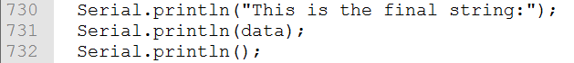

I also modify load_data() function.

I add a local variable char temp_encryption_key[25]. I use char temp_encryption_key[25] to convert string to byte array. I tried to convert const char array to byte array directly but I failed. Therefore, I first convert const char array to String then convert String to Byte array.

For the while loop, I change the count from 6 to 7 because we now have to read one more field.



I also add the following to accomplish the retrieve process.



The purpose of following code is to convert const char to string then convert string to byte array finally. I also use Serial.println() so you can view it for debug purpose.

